**Report Milestone #3**

**ECSE 542: Human Computer Interaction**

**Submitted by: Maninder Bir Singh Gulshan**

**Three participants:**

**P1**: Abhishree; Masters’ student in Electrical and Computer Engineering, McGill University, Montreal, Quebec, Canada

|  |  |  |  |
| --- | --- | --- | --- |
| **Task** | **Say This** | **Do This** | **Note Down** |
| 1 | **Make the drone take off.** | Wait for **Open Palm** | Time: 1 sec |
| 2 | **Make it go up.** | Wait for **Thumbs Up** | Time: 2 sec |
| 3 | **Turn it left.** | Wait for **Point Left** | Time: 1.5 sec |
| 4 | **Land it.** | Wait for **Fist** | Time: 0.5 sec |
| 5 | **Do nothing with hand.** |  | Did it stay still (HOVER)? Y/N: Yes |

|  |  |  |
| --- | --- | --- |
| **#** | **Question** | **Write Down Answer** |
| Q1 | **How easy was it to control the drone?** | Very cool, very cool |
| Q2 | **Did the big arrow and label help you know what the system saw?** | The user was 75% clear. |
| Q3 | **Would you trust this in a real drone?** | Sure. |

**Snips of P1 performing the tasks:**

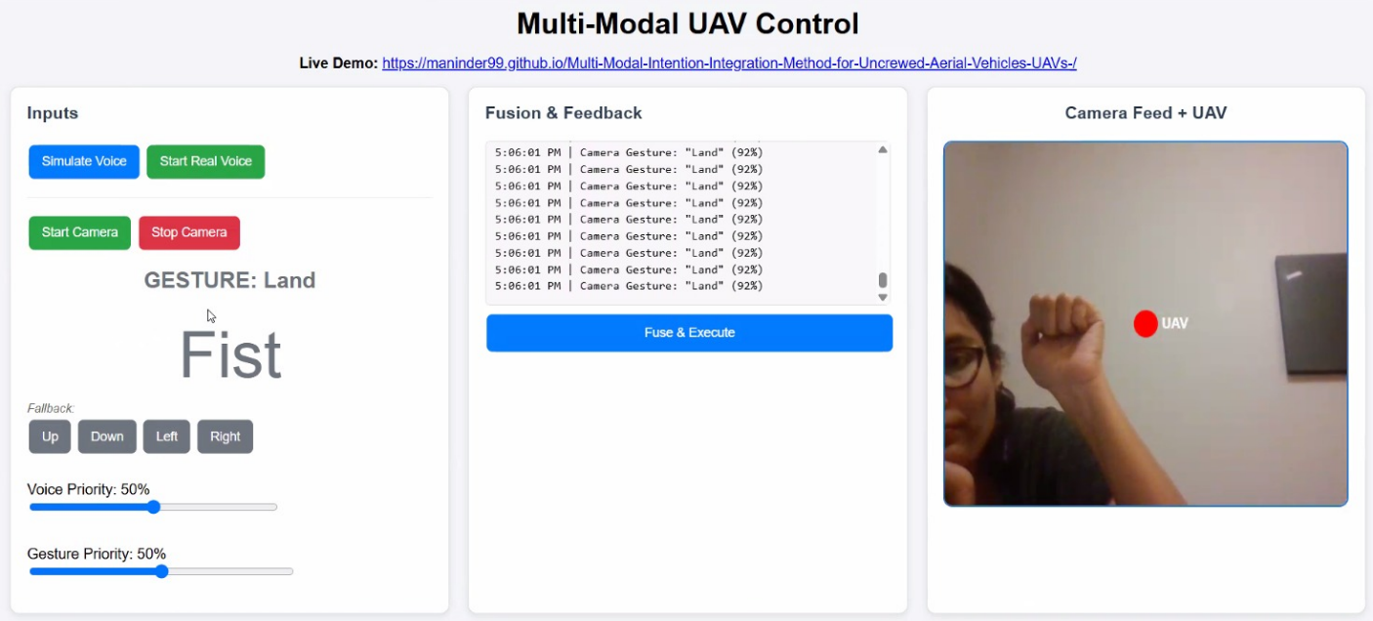

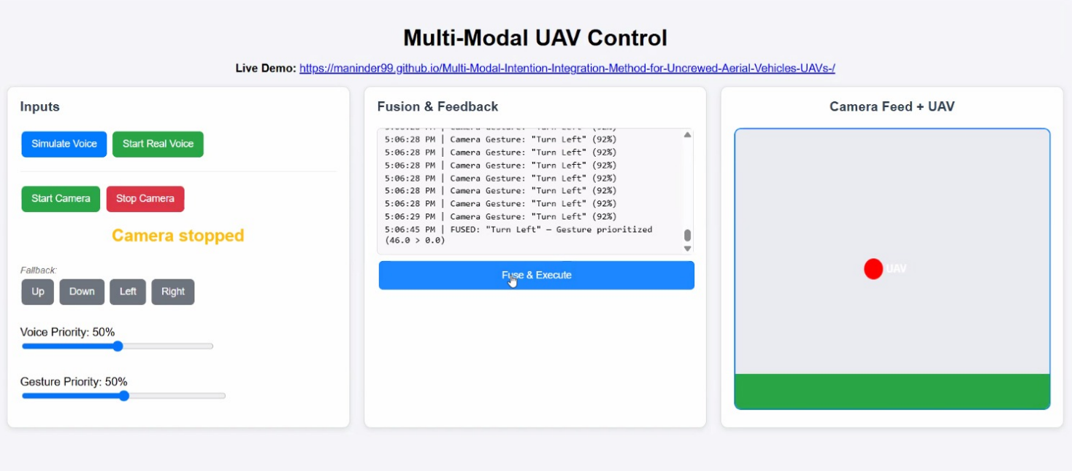

**P2**: Prerna Gupta; Masters’ student in Cloud Computing and Network Infrastructure, KTH, Stockholm, Sweden

|  |  |  |  |
| --- | --- | --- | --- |
| **Task** | **Say This** | **Do This** | **Note Down** |
| 1 | **Make the drone take off.** | Wait for **Open Palm** | Time: 1.2 sec |
| 2 | **Make it go up.** | Wait for **Thumbs Up** | Time: 2.5 sec |
| 3 | **Turn it left.** | Wait for **Point Left** | Time: 2 sec |
| 4 | **Land it.** | Wait for **Fist** | Time: 1 sec |
| 5 | **Say Turn Right but do nothing with hand.** |  | Did it turn RIGHT? Y/N: Yes |

|  |  |  |
| --- | --- | --- |
| **#** | **Question** | **Write Down Answer** |
| Q1 | **How easy was it to control the drone?** | New and different way to control the drone. |
| Q2 | **Did the big arrow and label help you know what the system saw?** | Majority of the time, the system was able to see what I was doing. |
| Q3 | **Would you trust this in a real drone?** | Yes, but it should work with 100% accuracy. |

**Snips of P2 performing the tasks:**

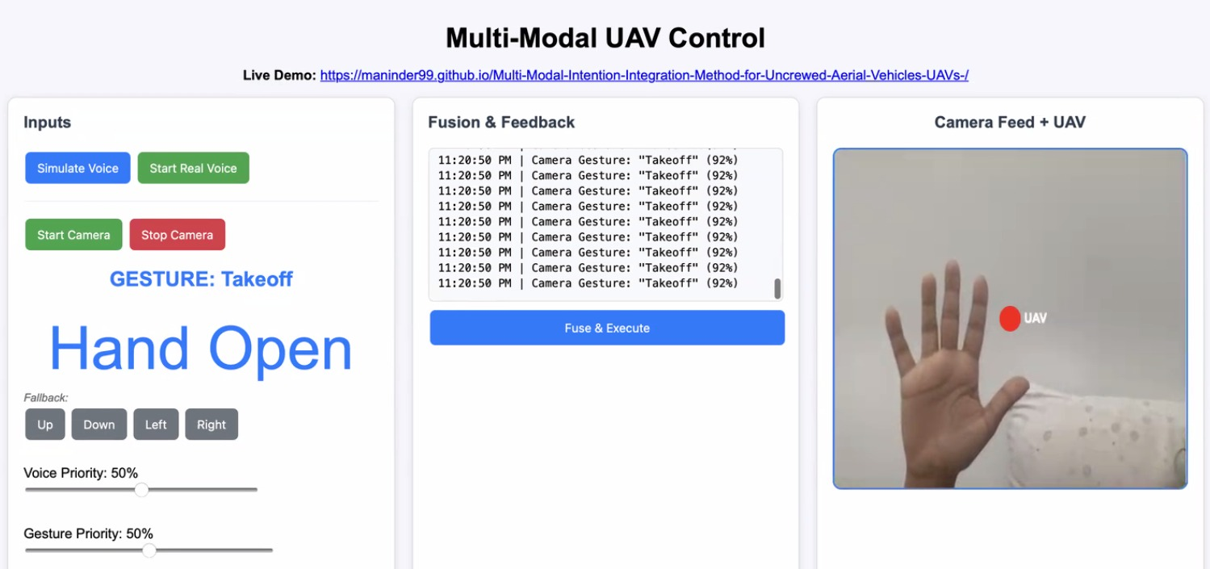

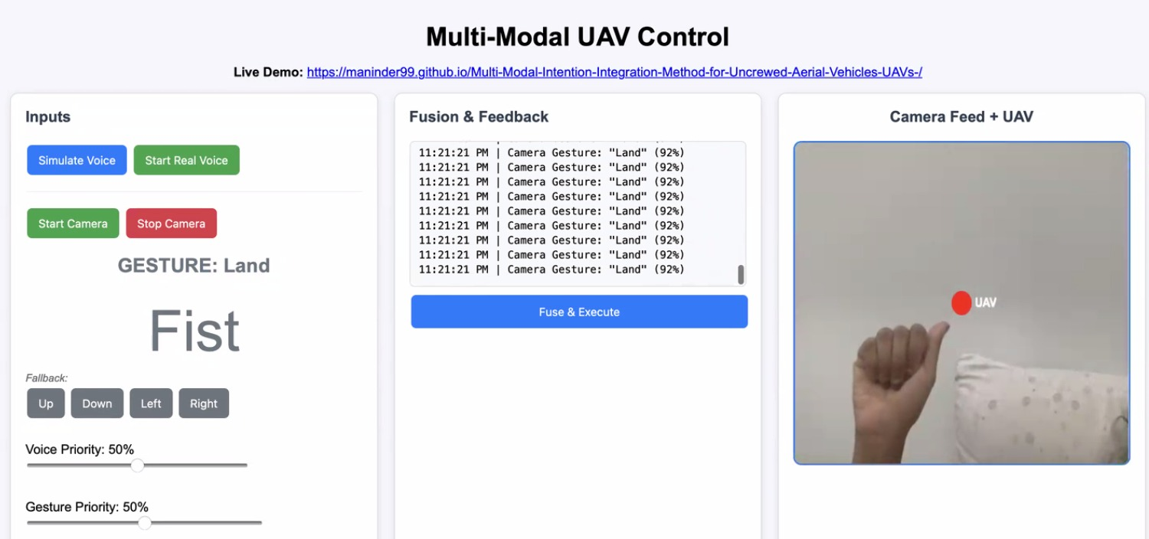

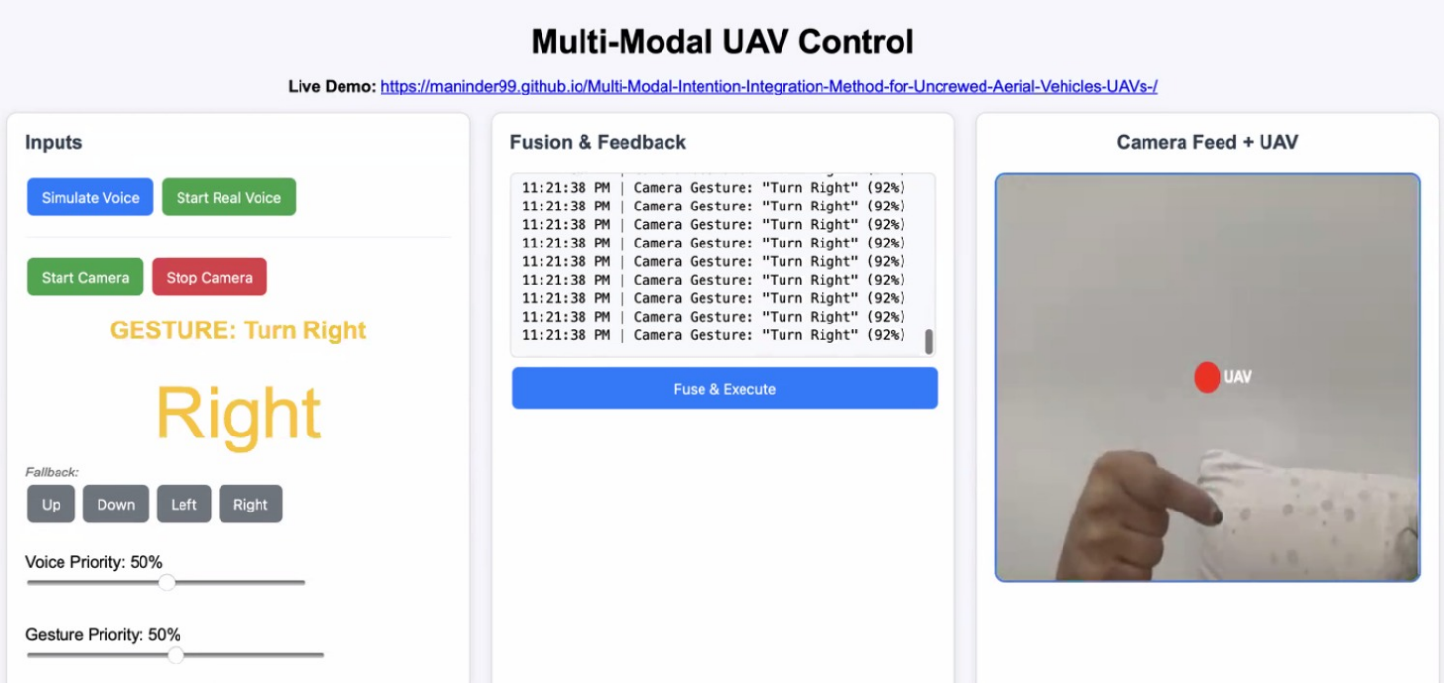

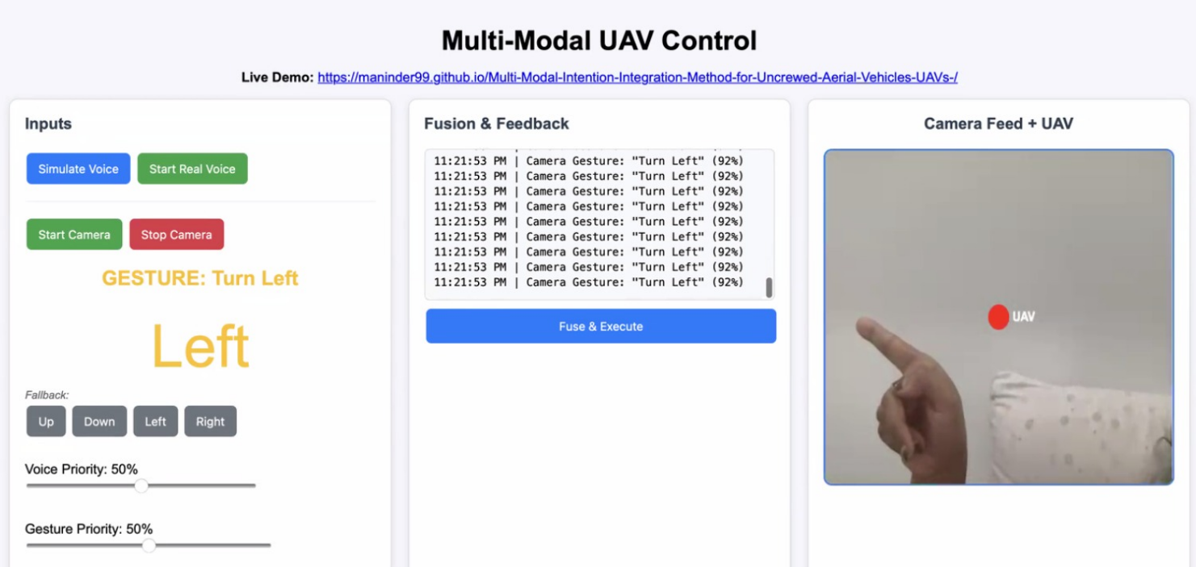

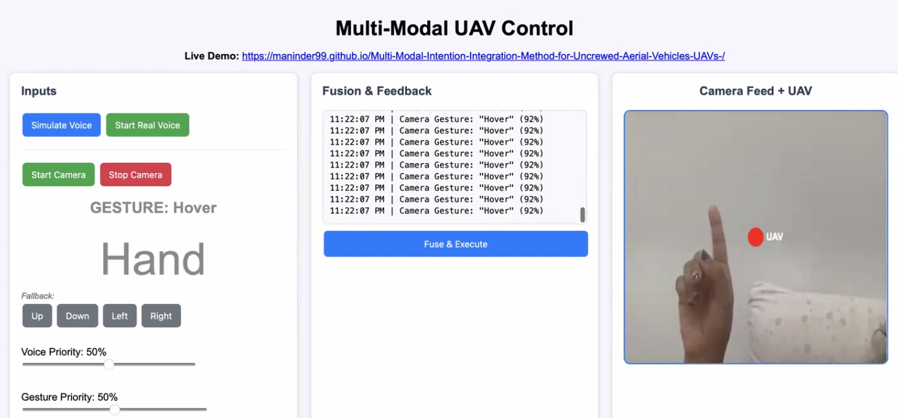

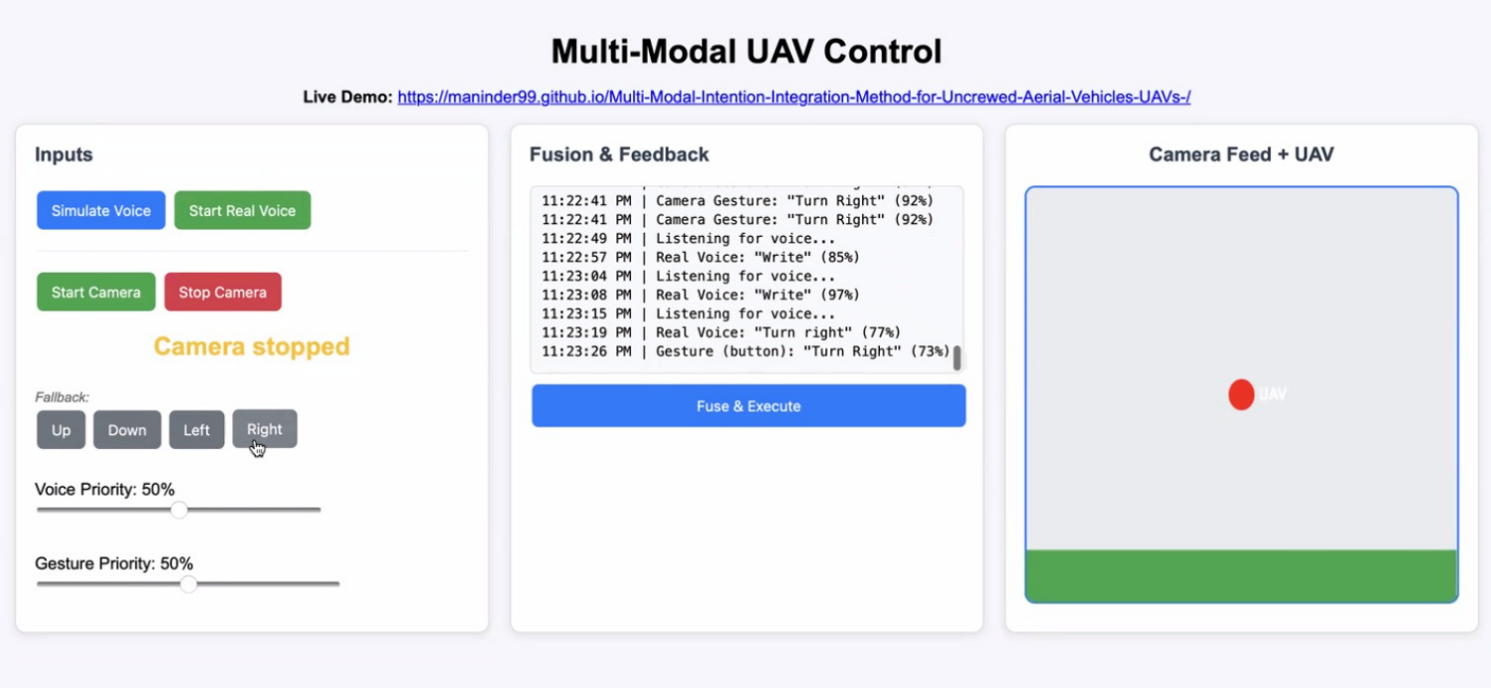

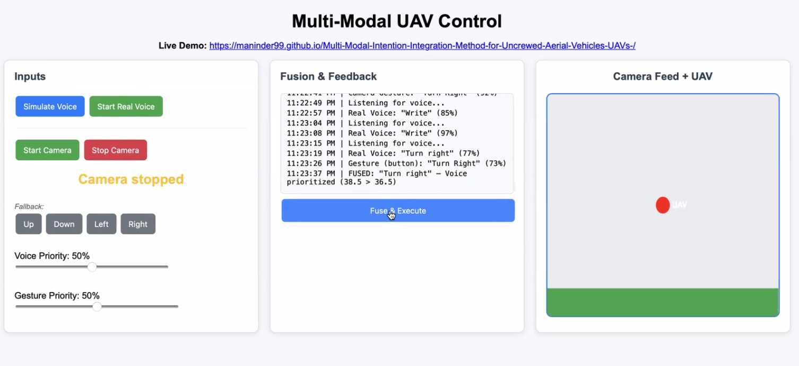

**P3**: Ridhima Saxena; Masters’ student in Biotechnology, McGill University, Montreal, Quebec, Canada

|  |  |  |  |
| --- | --- | --- | --- |
| **Task** | **Say This** | **Do This** | **Note Down** |
| 1 | **Make the drone take off.** | Wait for **Open Palm** | Time: 1.5 sec |
| 2 | **Make it go up.** | Wait for **Thumbs Up** | Time: 2.2 sec |
| 3 | **Turn it left.** | Wait for **Point Left** | Time: 1 sec |
| 4 | **Land it.** | Wait for **Fist** | Time: 0.5 sec |
| 5 | **Say Turn Right but do nothing with hand.** |  | Did it turn RIGHT? Y/N: Yes |

|  |  |  |
| --- | --- | --- |
| **#** | **Question** | **Write Down Answer** |
| Q1 | **How easy was it to control the drone?** | Very easy |
| Q2 | **Did the big arrow and label help you know what the system saw?** | Yes, it was very clear that the system was able to understand what I was doing. |
| Q3 | **Would you trust this in a real drone?** | Yes, for sure, absolutely. |

**Snips of P3 performing the tasks:**

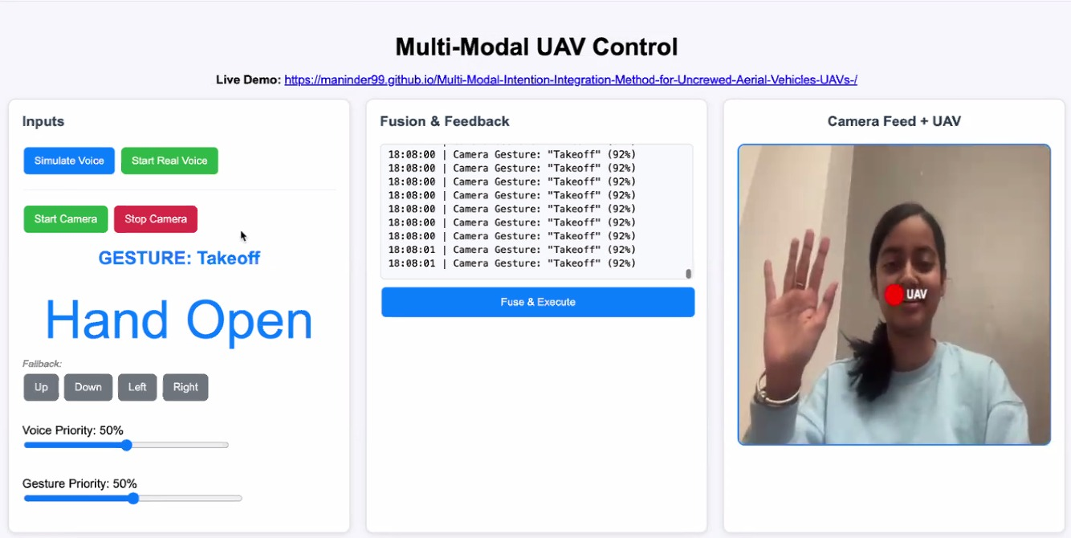

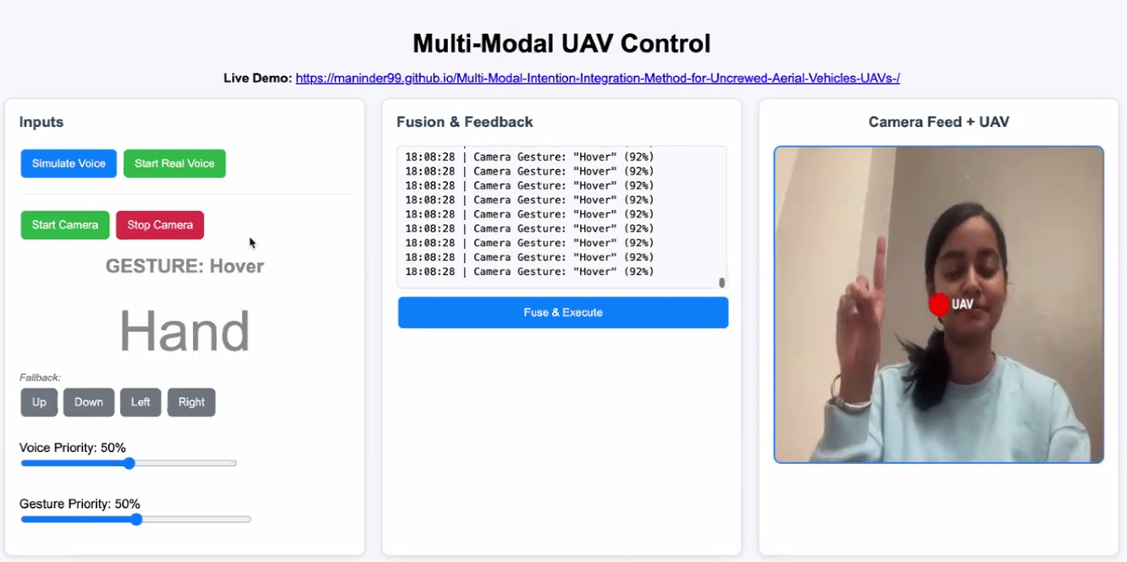

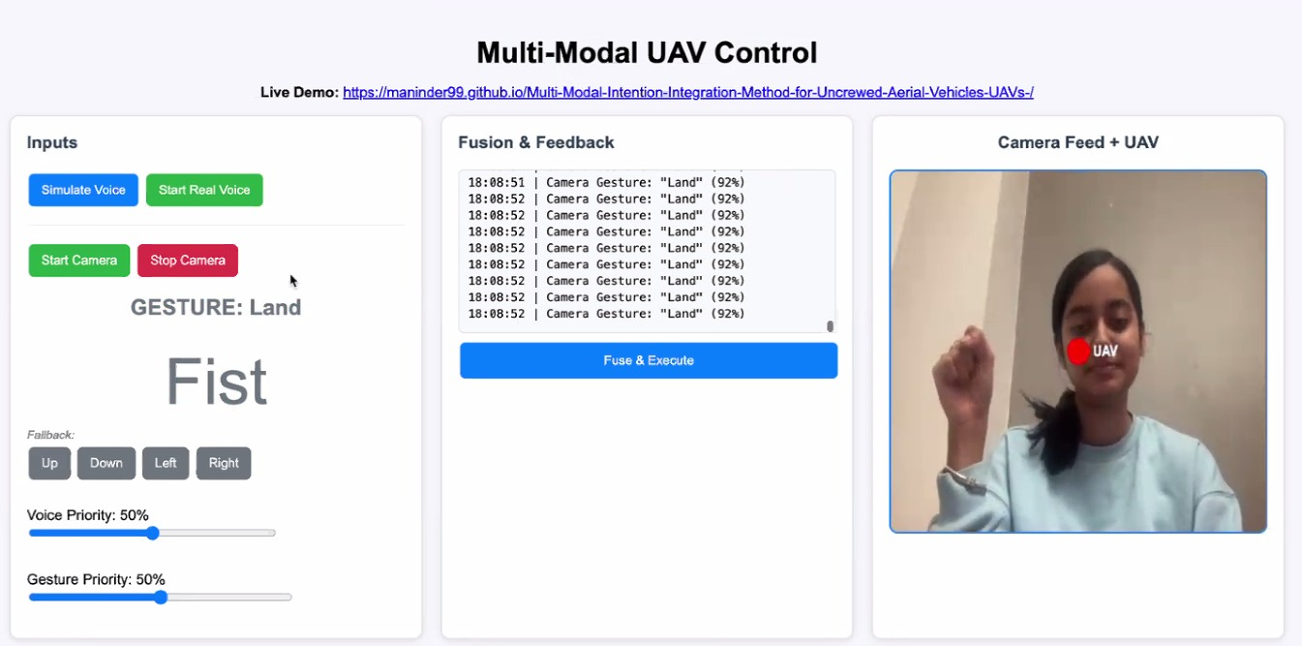

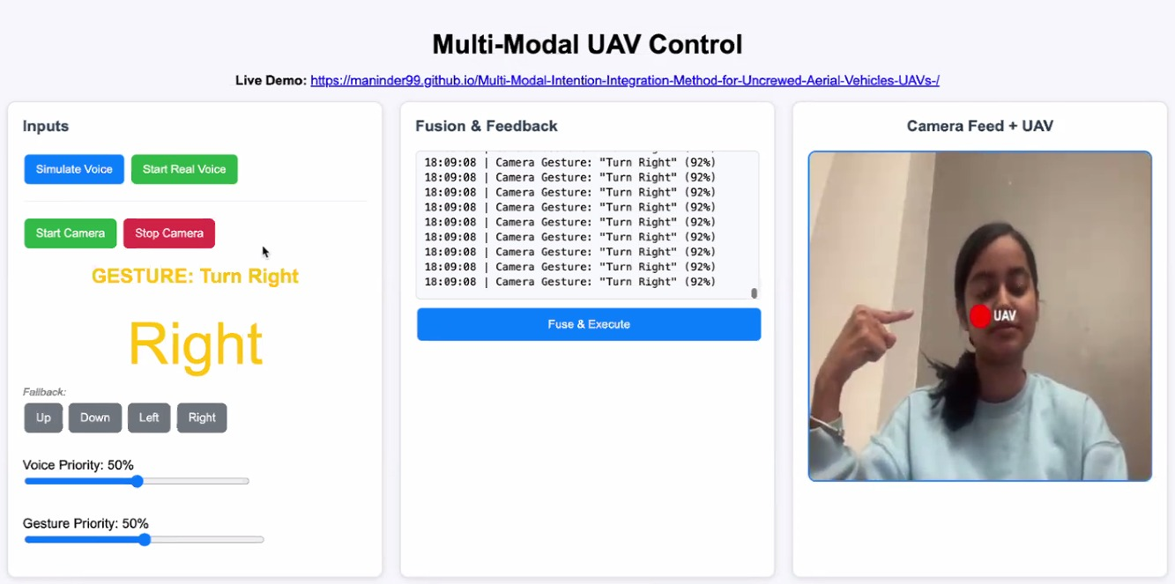

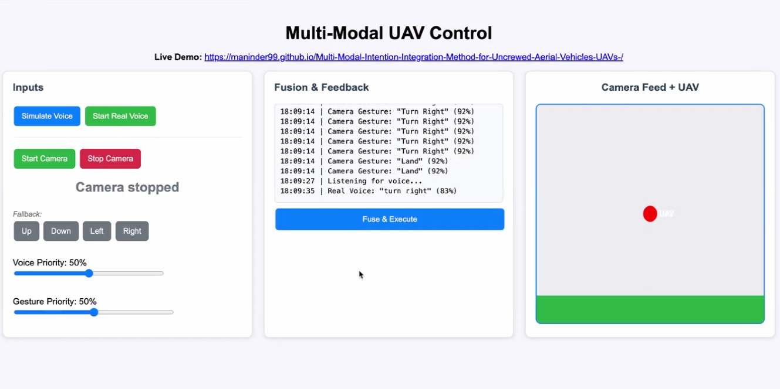

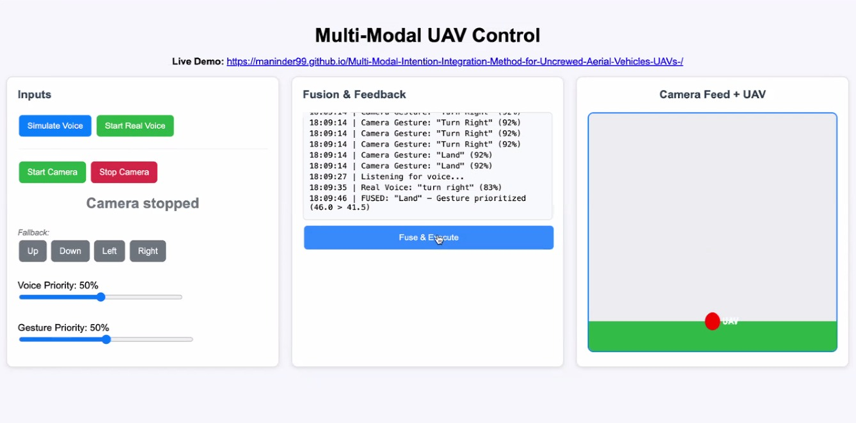

SUS form Say: Please rate 1 to 5 (**1 = strongly disagree, 5 = agree**)

|  |  |  |  |  |
| --- | --- | --- | --- | --- |
| **#** | **Question** | **P1 Answer** | **P2 Answer** | **P3 Answer** |
| 1 | I would use this system often | 4 | 4 | 5 |
| 2 | It was too complex | 2 | 1 | 1 |
| 3 | Easy to use | 4 | 5 | 4 |
| 4 | Needed tech support | 2 | 1 | 1 |
| 5 | Functions well integrated | 4 | 3 | 5 |
| 6 | Too inconsistent | 2 | 3 | 1 |
| 7 | Most people learn fast | 4 | 5 | 5 |
| 8 | Cumbersome | 1 | 1 | 1 |
| 9 | Confident using it | 5 | 4 | 5 |
| 10 | Needed to learn a lot first | 1 | 1 | 2 |

SUS score for all the participants:

|  |  |
| --- | --- |
| **Participant** | **SUS Score** |
| P1 | 82.5 (33*2.5) |
| P2 | 85 (34*2.5) |
| P3 | 95 (38*2.5) |
| AVG | 87.5 |

**NASA-TLX**: Say: **Rate how much effort each was (0 = none, 100 = max)**

|  |  |  |  |  |
| --- | --- | --- | --- | --- |
| **Dimension** | **P1** | **P2** | **P3** | **Avg** |
| Mental | 20 | 25 | 15 | **20** |
| Physical | 15 | 20 | 10 | **15** |
| Temporal | 25 | 20 | 20 | **22** |
| Performance | 85 | 80 | 90 | **85** |
| Effort | 20 | 25 | 15 | **20** |
| Frustration | 10 | 15 | 5 | **10** |
| **Overall** | | | | **28.7 → 30** |